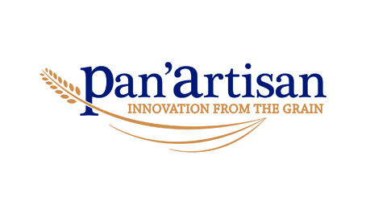
JOB DESCRIPTION
Position: BAKING SUPERVISOR
Report to: SENIOR PRODUCTION SUPERVISOR
Hours of work: Shifts between 6am and 10pm from Monday to Friday
Shift between 6am and 12pm on Saturday if required.

Job purpose: To manage the baking ensuring smooth and efficient operation of ovens and provers to produce a consistent quality product, conforming to the required standards.

Responsibilities:
- Completion of the line start-up check sheet, thereby ensuring all equipment is suitable for food production.
- Check and ensure that all equipment is in good working order, reporting any issues to the engineers.
- Production of products according to the plan, ensuring all orders are fulfilled in time.
- Ensuring that the product quality is upheld, working with the Technical and NPD departments should any issues arise.
- Ensure that the line is kept in a satisfactory standard and adhering to hygiene and housekeeping standards by adopting a clean as you go approach.
- Adherence to processes and ensure that the quality of the products meet the required company standards.
- Managing the materials and staff to achieve targeted yields and productivity measures.
- Accurate and timely completion of all required documentation in an eligible manner.
- Ongoing mentoring of staff to achieve the required results.
- Ensuring that health and safety policies are adhered to, reporting any issues, including near misses.
- Assist with the induction of new and temporary staff when required, ensuring that they have sufficient understanding of the company’s processes and procedures, including health & safety requirements.
- Be accountable for all equipment, production and staff associated to the line.
- Comply with all regulatory and company standards as well as operate according to Good Manufacturing Standards.
- Ensure that CCP’s are adhered to and HACCP principles are applied, ensuring food safety at all times.
- To perform any other reasonable tasks requested by supervisors and managers.
Key qualities and skills:
- Have a good command in English, written and spoken.
- A good understanding of the line responsible for and a willingness to learn.
- Confident in managing people with good interpersonal skills
- An understanding of Health and Safety.
- The ability to work to tight timelines.

Name:

Sign:

Date:

